COMP1921: SDL Game

i) Structure of the code

Modules:
main.c – This contains the input for controlling the red square and also deals with completing and exiting the game.
game.c – This contains most of the functions used in main.c
AI.c – This dealt with how the blue squares moved and reacted with the player when collided into
game.h – This contains all the functions that are used in the two C files above

Functions:

ii.) My Project

For my project, I chose to create a using the SDL libraries. My game involves the player (controlling red square) crossing from the left side of the window to the other, with the aim being to reach the black gate on the right in the middle. There are obstacles in the way of the player, some which are stationary and some that move vertically. If the player hits any of these obstacles then they will be transported back to the starting position as shown below.

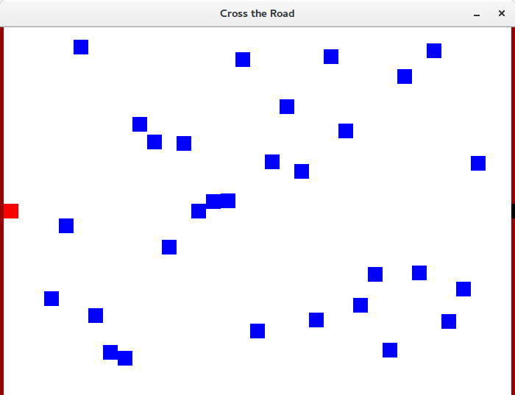
The final step was programming the blue squares to move vertically.

Creating code for when the player collided with a blue box

iii.) Test cases and results

1) Defining collision type
There are three types of collisions that are dealt with in the game and various messages are printed to describe these.

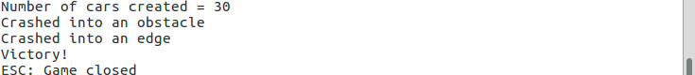
The first collision is if the player controlled square collides with an obstacle square, which the message “Crashed into an obstacle” is printed. The second type is if the player crashes into the edge of the map that is rendered, which will give a seperate message “Crashed into an edge”. For these first two types of collision, the player is reset to the starting position on the map, as shown below.

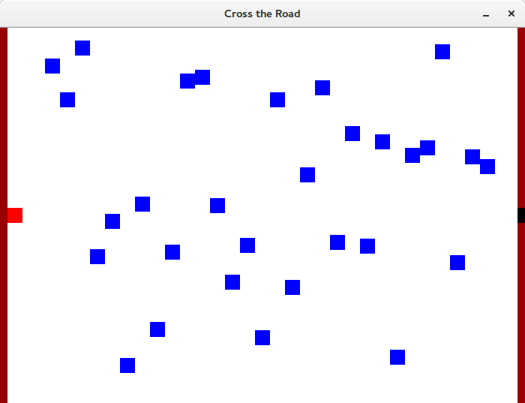

The last one is if the player reaches the black gate at the other end of the map, thus completing the game, so “Victory!” is displayed. Here the player will not be reset because the game is over and the map is cleared

2) Error checking for True Type Fonts
There should be a message after completing the game that says “Victory!” that uses the Gobold Blocky Italic.otf file in the “game/fonts” folder, as well a a “Victory!” message in the terminal.

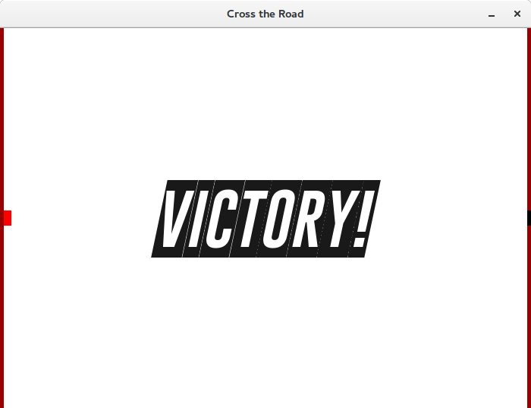

However, when there is not a valid font file in the “game/fonts” it will display an error message as shown below. The game should still run as normal, but not display the message above after the game is completed; instead it should produce an error message.

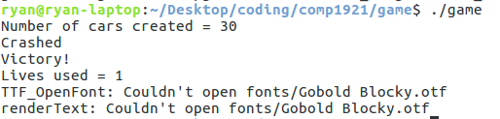

4.) Exiting the game
There are two ways of exiting the game, the first is to simple press the ESC key and the other is to use the mouse and click on the X button in the corner of the window.

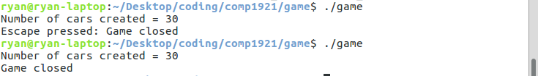
The differences are shown in the messages that are printed out in the terminal with the ESC key explicitly stating that it has been pressed and the X button will only give a normal “Game closed” message.

iv.) Personal reflection

Editing the movement to suit my needs was the first obstacle. The program that I had initially used as a template, eatSquares, utilised a different method for movement so I had to create a new one that registered when the arrow keys and ESC key was pressed. Next I needed to change the loop in my main function to incorporate the new changes that I made.

